Embedded Programming
assignment 3

Analysis
The system is a small environmental monitor. A BME280 sensor measures the temperature and the air pressure. The system has three states: IDLE with the red led, MONITOR with the green led and WARNING with the orange led. In IDLE nothing happens until the start button is pressed. In MONITOR the temperature and pressure are read and printed every second. If the temperature is higher than 25 °C the system goes to WARNING, where the sensor is not read for 10 seconds, after that it goes back to MONITOR. In MONITOR the stop button brings the system back to IDLE.
The buttons are read with hardware interrupts (falling edge) with a debounce of 200 ms. The start button only works in IDLE and the stop button only works in MONITOR. The interrupts only set a flag, the states are handled in the loop with an enum and a switch.
Inputs are the start and stop buttons on PIN numbers 34 and 35 (they need an external pull-up resistor) and the BME280 sensor on the I2C pins SDA 27 and SCL 26. Outputs are the red, orange and green leds on PIN numbers 21, 4 and 22.

State diagram

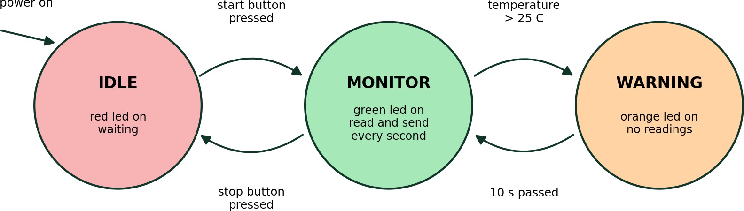

Flowchart
